

Database Systems
( Course Code: CSC270 )

Name: Muhammad Abdullah
Roll No # FA24-BSE-042
Instructor Name: Dr Rubina Adnan

Theory Assignment# 2

Problem 1: Bioinformatics Database
The bioinformatics system manages patients along with their tissue sample tag libraries. Each tag may be linked to a gene, and genes can be referenced in multiple research articles, introducing several many-to-many relationships. Additionally, the relationship between patients and tags includes an extra attribute (count), which requires modeling it as an associative entity rather than a simple join table.

ER Diagram

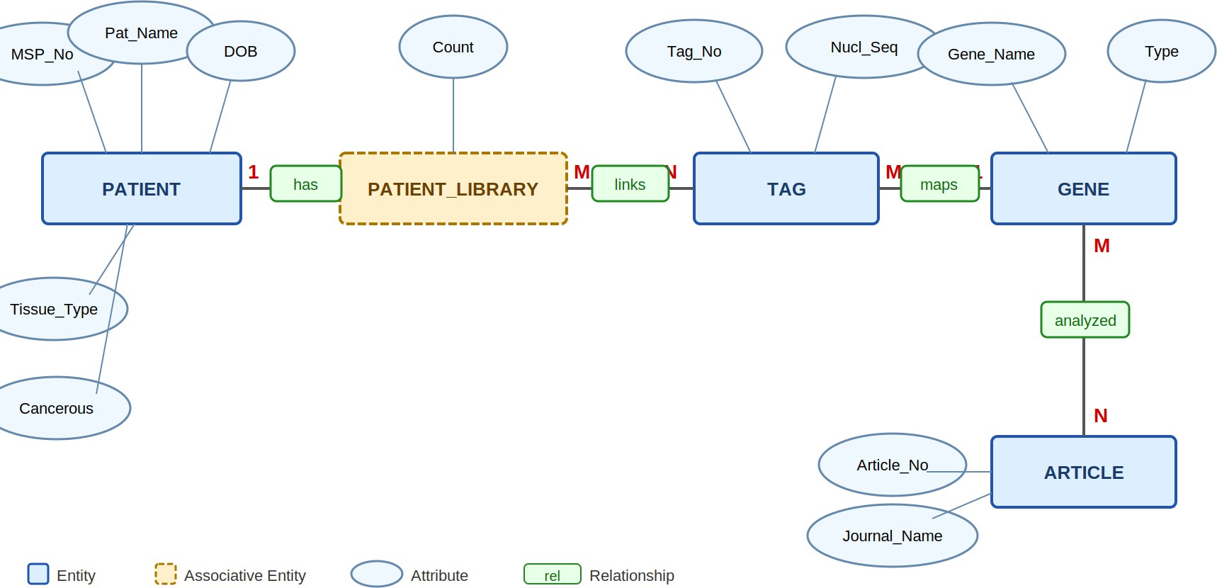

Figure 1: ER Diagram – Bioinformatics Database

Relational Schema
The following tables are derived from the ER diagram, where primary keys (PK) uniquely identify each record and foreign keys (FK) establish relationships between the tables.

PATIENT
Attribute | Type | Constraint
MSP_No | VARCHAR(20) | PK – Unique patient identifier
Patient_Name | VARCHAR(100) | NOT NULL

Date_of_Birth | DATE | NOT NULL
Tissue_Type | VARCHAR(50) | NOT NULL
Is_Cancerous | CHAR(1) | CHECK ('Y','N') – indicates cancer status

TAG
Attribute | Type | Constraint
Tag_No | VARCHAR(20) | PK – Unique tag identifier
Nucleotide_Sequence | TEXT | NOT NULL UNIQUE
Gene_Name | VARCHAR(100) | FK → GENE(Gene_Name) – nullable (tag may not be mapped)

GENE
Attribute | Type | Constraint
Gene_Name | VARCHAR(100) | PK – Unique gene name
Gene_Type | VARCHAR(50) | NOT NULL

ARTICLE
Attribute | Type | Constraint
Article_No | VARCHAR(20) | PK – Unique article identifier
Journal_Name | VARCHAR(150) | NOT NULL

PATIENT_LIBRARY (Associative – stores tag count per patient)
Attribute | Type | Constraint
MSP_No | VARCHAR(20) | PK, FK → PATIENT(MSP_No)
Tag_No | VARCHAR(20) | PK, FK → TAG(Tag_No)
Count | INT | NOT NULL – occurrences of tag in library

GENE_ARTICLE (M:N between GENE and ARTICLE)
Attribute | Type | Constraint
Gene_Name | VARCHAR(100) | PK, FK →  GENE(Gene_Name)

Article_No | VARCHAR(20) | PK, FK →  ARTICLE(Article_No)

Problem 2: Blue Wave Water Sports Center Database

Blue Wave operates two distinct services—Jet Ski rentals and Surfboard sales. While both equipment types share a common attribute (Model Name), they differ in pricing structure (hourly rental vs. fixed sale price). Similarly, tourists share general attributes like contact information but differ in role-specific details. These variations are best modeled using ISA hierarchies to maintain a clean and structured design.

ER Diagram
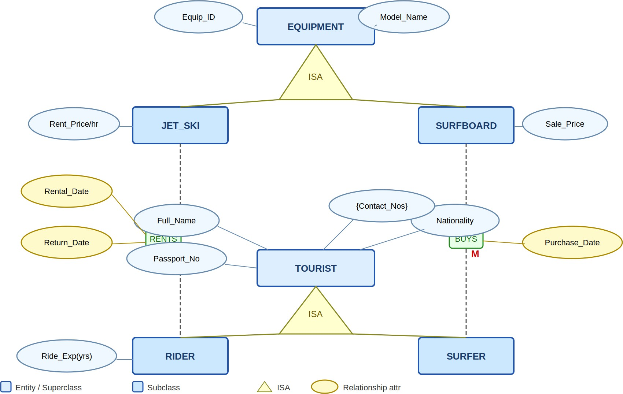

Figure 2: ER Diagram – Blue Wave Water Sports Center

Relational Schema

EQUIPMENT (Superclass)
Attribute | Type | Constraint
Equipment_ID | VARCHAR(20) | PK
Model_Name | VARCHAR(100) | NOT NULL
Equip_Type | CHAR(1) | CHECK('J','S') – J=JetSki,  S=Surfboard

JET_SKI (Subclass of EQUIPMENT)
Attribute | Type | Constraint
Equipment_ID | VARCHAR(20) | PK, FK →  EQUIPMENT(Equipment_ID  )
Rental_Price_Per_Hour | DECIMAL(8,2) | NOT NULL

SURFBOARD (Subclass of EQUIPMENT)
Attribute | Type | Constraint
Equipment_ID | VARCHAR(20) | PK, FK →  EQUIPMENT(Equipment_ID  )
Sale_Price | DECIMAL(8,2) | NOT NULL

TOURIST (Superclass)
Attribute | Type | Constraint
Passport_No | VARCHAR(30) | PK
Full_Name | VARCHAR(100) | NOT NULL
Nationality | VARCHAR(60) | NOT NULL
Tourist_Type | CHAR(1) | CHECK('R','S') – R=Rider,  S=Surfer

TOURIST_CONTACT (Multi valued attribute)
Attribute | Type | Constraint
Passport_No | VARCHAR(30) | PK, FK →  TOURIST(Passport_No)
Contact_Number | VARCHAR(20) | PK

RIDER (Subclass of TOURIST)
Attribute | Type | Constraint
Passport_No | VARCHAR(30) | PK, FK →  TOURIST(Passport_No)
Riding_Experience_Years | INT | NOT NULL

SURFER (Subclass of TOURIST)

Attribute | Type | Constraint

Passport_No | VARCHAR(30) | PK, FK →  TOURIST(Passport_No)

RENTAL (M:N between RIDER and JET_SKI)
Attribute | Type | Constraint
Passport_No | VARCHAR(30) | PK, FK →  RIDER(Passport_No)
Equipment_ID | VARCHAR(20) | PK, FK →  JET_SKI(Equipment_ID)
Rental_Date | DATE | PK – part of composite key
Return_Date | DATE | NOT NULL

PURCHASE (M:1 between SURFER and SURFBOARD)
Attribute | Type | Constraint
Equipment_ID | VARCHAR(20) | PK, FK →  SURFBOARD(Equipment_I D)
Passport_No | VARCHAR(30) | FK → SURFER(Passport_No)
Purchase_Date | DATE | NOT NULL

Problem 3: Football Match Database

This is the most entity-intensive scenario among the five. Football clubs serve as the central hub, connecting to games, personnel, uniforms, jargon, reference materials, deliverables, and value systems. A key design decision is modeling Game_Player as an associative entity, since a player’s position depends on a specific game context rather than being a fixed attribute of the player.

ER Diagram
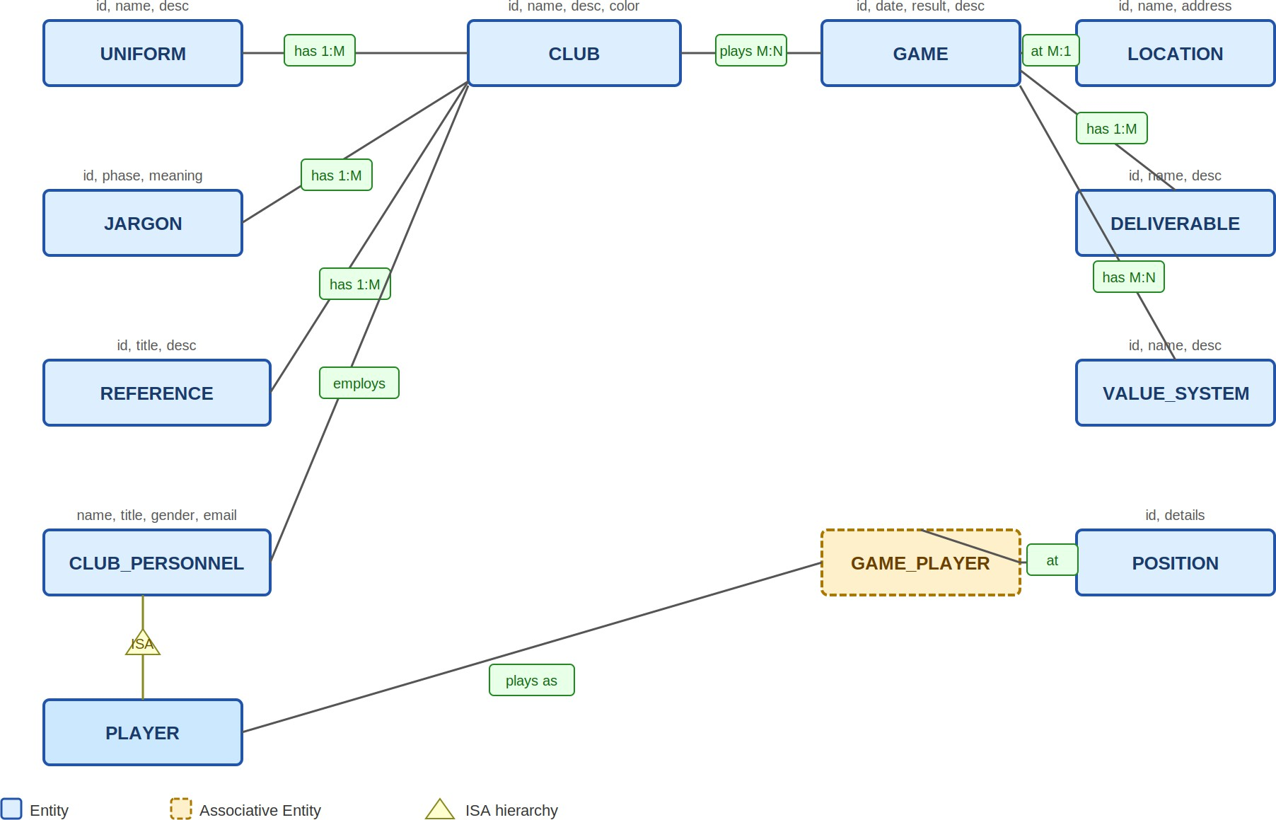

Figure 3: ER Diagram – Football Match Database

Relational Schema

CLUB
Attribute | Type | Constraint
Club_ID | VARCHAR(20) | PK
Club_Name | VARCHAR(100) | NOT NULL UNIQUE
Description | TEXT
Color | VARCHAR(50)

UNIFORM
Attribute | Type | Constraint
Uniform_ID | VARCHAR(20) | PK
Uniform_Name | VARCHAR(100) | NOT NULL
Description | TEXT
Club_ID | VARCHAR(20) | FK → CLUB(Club_ID)

JARGON
Attribute | Type | Constraint
Jargon_ID | VARCHAR(20) | PK
Phase | VARCHAR(200) | NOT NULL
Meaning | TEXT | NOT NULL
Club_ID | VARCHAR(20) | FK → CLUB(Club_ID)

REFERENCE_MATERIAL
Attribute | Type | Constraint
Ref_ID | VARCHAR(20) | PK
Title | VARCHAR(200) | NOT NULL
Description | TEXT
Club_ID | VARCHAR(20) | FK → CLUB(Club_ID)

CLUB_PERSONNEL
Attribute | Type | Constraint
Personnel_ID | VARCHAR(20) | PK
Name | VARCHAR(100) | NOT NULL
Title | VARCHAR(60)
Gender | VARCHAR(10)
Address | VARCHAR(200)
Email | VARCHAR(100)
Contact | VARCHAR(30)
Club_ID | VARCHAR(20) | FK → CLUB(Club_ID)

PLAYER (Subclass of CLUB_PERSONNEL)

Attribute | Type | Constraint
Personnel_ID | VARCHAR(20) | PK, FK → CLUB_PERSONNEL(Perso  nnel_ID)

GAME
Attribute | Type | Constraint
Game_ID | VARCHAR(20) | PK
Game_Date | DATE | NOT NULL
Results | VARCHAR(50)
Description | TEXT
Location_ID | VARCHAR(20) | FK → LOCATION(Location_ID)

CLUB_GAME (M:N – two clubs per game)
Attribute | Type | Constraint
Game_ID | VARCHAR(20) | PK, FK → GAME(Game_ID)
Club_ID | VARCHAR(20) | PK, FK → CLUB(Club_ID)
Role | VARCHAR(20) | CHECK('Home','Away')

LOCATION
Attribute | Type | Constraint
Location_ID | VARCHAR(20) | PK
Location_Name | VARCHAR(100) | NOT NULL
Address | VARCHAR(200)

DELIVERABLE
Attribute | Type | Constraint
Deliverable_ID | VARCHAR(20) | PK
Name | VARCHAR(100) | NOT NULL
Description | TEXT
Game_ID | VARCHAR(20) | FK → GAME(Game_ID)

VALUE_SYSTEM

Attribute | Type | Constraint

VS_ID | VARCHAR(20) | PK
Name | VARCHAR(100) | NOT NULL
Description | TEXT

GAME_VALUE_SYSTEM
Attribute | Type | Constraint
Game_ID | VARCHAR(20) | PK, FK → GAME(Game_ID)
VS_ID | VARCHAR(20) | PK, FK → VALUE_SYSTEM(VS_ID)

POSITION
Attribute | Type | Constraint
Position_ID | VARCHAR(20) | PK
Position_Details | TEXT

GAME_PLAYER (Associative – Player in Game at Position)
Attribute | Type | Constraint
Game_ID | VARCHAR(20) | PK, FK → GAME(Game_ID)
Personnel_ID | VARCHAR(20) | PK, FK →  PLAYER(Personnel_ID)
Position_ID | VARCHAR(20) | FK → POSITION(Position_ID)

Problem 4: Chughtai Group of Pharmacies Database

The most challenging aspect of this design is the DRUG table. Since trade names are only unique per company and not globally, the table requires a composite primary key consisting of (Trade_Name + Company_Name). This composite key then carries over into both the PRESCRIPTION and PHARMACY_DRUG tables. All other elements adhere to standard normalization principles.

ER Diagram
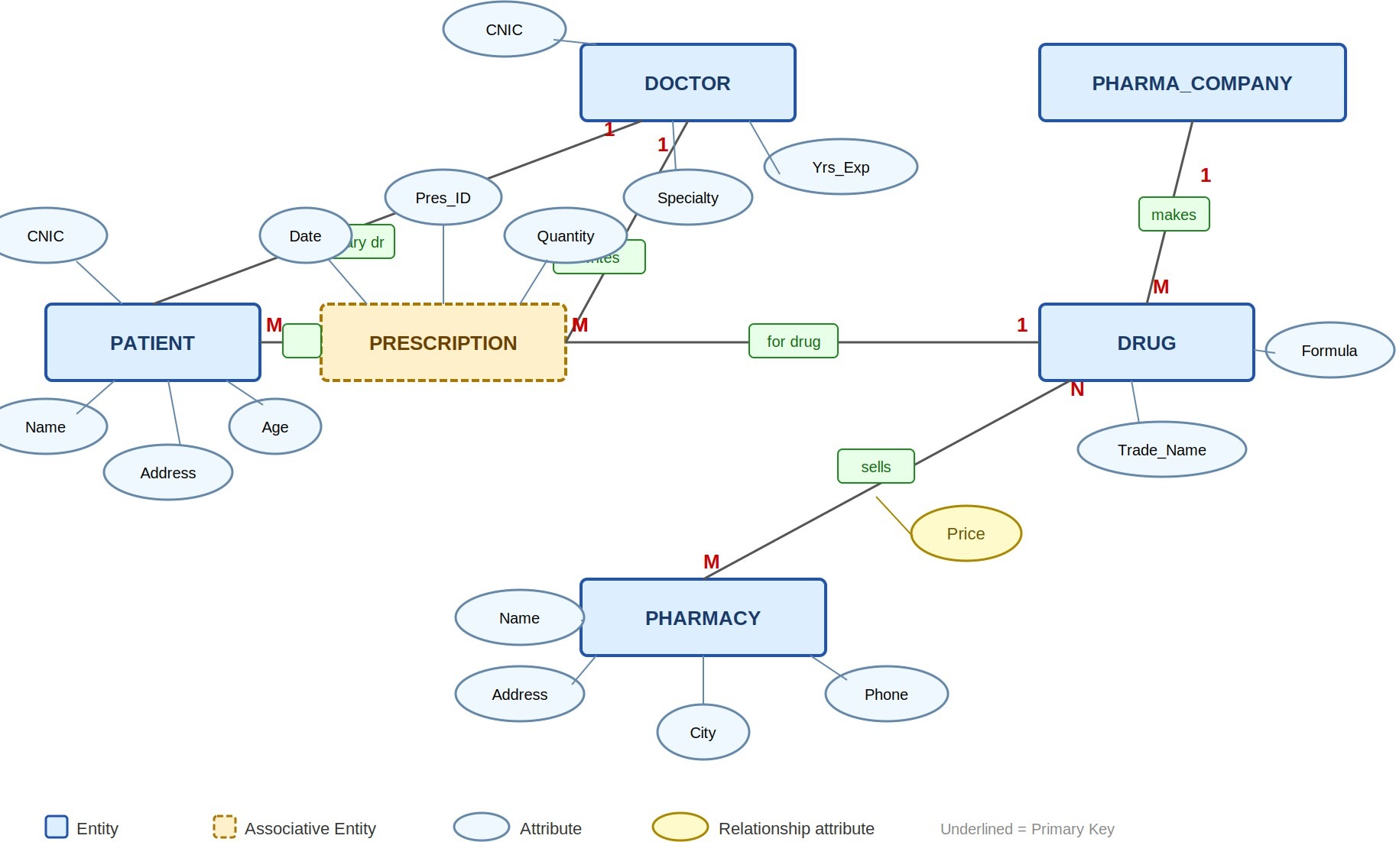

Figure 4: ER Diagram – Chughtai Pharmacies Database

Relational Schema

PATIENT
Attribute | Type | Constraint
CNIC | CHAR(13) | PK
Name | VARCHAR(100) | NOT NULL
Address | VARCHAR(200)
Age | INT | CHECK(Age > 0)

Doctor_CNIC | CHAR(13) | FK → DOCTOR(CNIC) –  primary doctor (M:1)

DOCTOR
Attribute | Type | Constraint
CNIC | CHAR(13) | PK
Name | VARCHAR(100) | NOT NULL
Specialty | VARCHAR(100) | NOT NULL
Years_of_Experience | INT | CHECK >= 0

PHARMA_COMPANY
Attribute | Type | Constraint
Company_Name | VARCHAR(150) | PK
Phone_Number | VARCHAR(20) | NOT NULL

DRUG (Trade_Name unique per company only → composite PK)
Attribute | Type | Constraint
Trade_Name | VARCHAR(100) | PK (part of composite)
Company_Name | VARCHAR(150) | PK (part of composite), FK  → PHARMA_COMPANY(Com  pany_Name)
Formula | VARCHAR(200) | NOT NULL

PHARMACY
Attribute | Type | Constraint
Pharmacy_Name | VARCHAR(150) | PK
Address | VARCHAR(200) | NOT NULL
City | VARCHAR(60) | NOT NULL
Phone_Number | VARCHAR(20) | NOT NULL

PHARMACY_DRUG (M:N – drug sold at pharmacy with price)
Attribute | Type | Constraint
Pharmacy_Name | VARCHAR(150) | PK, FK →  PHARMACY(Pharmacy_Na me)
Trade_Name | VARCHAR(100) | PK (part of FK → DRUG)

Company_Name | VARCHAR(150) | PK (part of FK → DRUG)
Price | DECIMAL(8,2) | NOT NULL – may vary per pharmacy

PRESCRIPTION (Ternary: Doctor prescribes Drug for Patient)
Attribute | Type | Constraint
Prescription_ID | VARCHAR(20) | PK
Prescription_Date | DATE | NOT NULL
Quantity | INT | NOT NULL
Doctor_CNIC | CHAR(13) | FK → DOCTOR(CNIC)
Patient_CNIC | CHAR(13) | FK → PATIENT(CNIC)
Trade_Name | VARCHAR(100) | FK (part) → DRUG
Company_Name | VARCHAR(150) | FK (part) → DRUG

Problem 5: University Database

The university schema enforces clear role separation. Assistant Professors teach up to five courses, Associate Professors oversee seminars, and Professors manage departments and handle funded projects. These three roles are represented as disjoint subclasses of a common FACULTY superclass.

ER Diagram
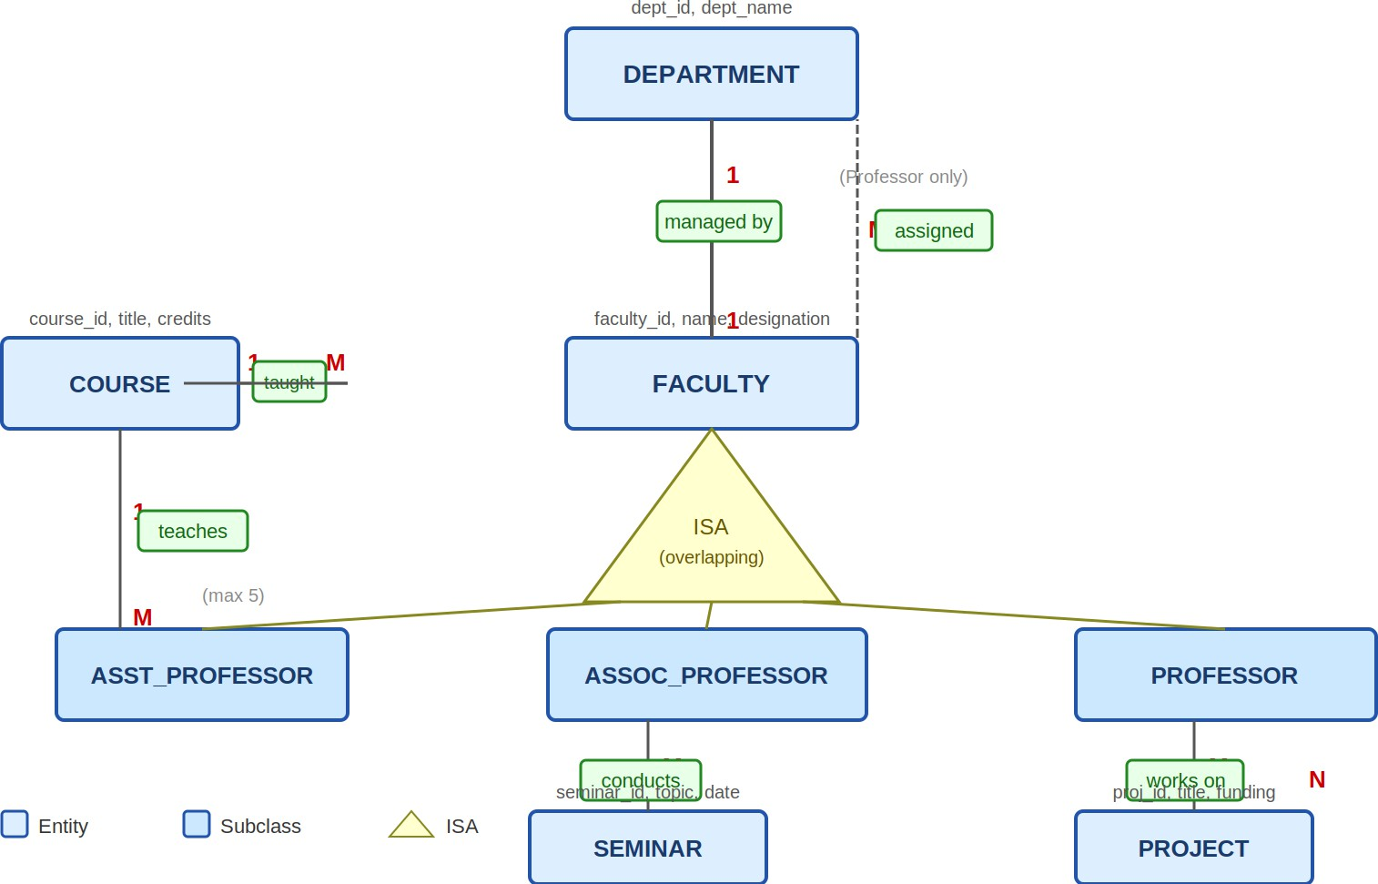
Figure 5: ER Diagram – University Database

Key Business Rules
    - A Professor manages each department one professor, one department (1:1).
    - Every faculty member belongs to exactly one department.
    - Only Assistant Professors teach courses. One course has at most one instructor; one instructor handles at most five courses.
    - Only Associate Professors conduct seminars.
    - Only Professors work on funded projects (M:N — a professor can run multiple projects).

Relational Schema

DEPARTMENT
Attribute | Type | Constraint
Dept_ID | VARCHAR(20) | PK
Dept_Name | VARCHAR(100) | NOT NULL UNIQUE
Manager_Faculty_ID | VARCHAR(20) | FK → PROFESSOR(Faculty_ID) – 1:1, NOT NULL

FACULTY (Superclass)
Attribute | Type | Constraint
Faculty_ID | VARCHAR(20) | PK
Name | VARCHAR(100) | NOT NULL
Designation | VARCHAR(20) | CHECK IN  ('Asst_Prof','Assoc_Prof','Pro fessor')
Dept_ID | VARCHAR(20) | FK → DEPARTMENT(Dept_ID) –  each faculty in one department

ASST_PROFESSOR (Subclass of FACULTY)
Attribute | Type | Constraint
Faculty_ID | VARCHAR(20) | PK, FK →  FACULTY(Faculty_ID)

ASSOC_PROFESSOR (Subclass of FACULTY)
Attribute | Type | Constraint
Faculty_ID | VARCHAR(20) | PK, FK →  FACULTY(Faculty_ID)

PROFESSOR (Subclass of FACULTY)
Attribute | Type | Constraint
Faculty_ID | VARCHAR(20) | PK, FK →  FACULTY(Faculty_ID)

COURSE
Attribute | Type | Constraint
Course_ID | VARCHAR(20) | PK

Title | VARCHAR(150) | NOT NULL
Credits | INT | DEFAULT 3
Faculty_ID | VARCHAR(20) | FK → ASST_PROFESSOR(Facult  y_ID) – nullable (unassigned)

SQL can't directly enforce that an Assistant Professor teaches no more than 5 courses a foreign key can't count.
SEMINAR
Attribute | Type | Constraint
Seminar_ID | VARCHAR(20) | PK
Topic | VARCHAR(200) | NOT NULL
Seminar_Date | DATE
Faculty_ID | VARCHAR(20) | FK → ASSOC_PROFESSOR(Facu  lty_ID) – only Assoc. Profs

PROJECT
Attribute | Type | Constraint
Project_ID | VARCHAR(20) | PK
Title | VARCHAR(200) | NOT NULL
Funding_Amount | DECIMAL(12,2)
Funding_Source | VARCHAR(150)

PROFESSOR_PROJECT (M:N – Professors work on Projects)
Attribute | Type | Constraint
Faculty_ID | VARCHAR(20) | PK, FK →  PROFESSOR(Faculty_ID)
Project_ID | VARCHAR(20) | PK, FK →  PROJECT(Project_ID)

